RAROA LIBRARY SURVEY 2012
- 137 responses (22% of Raroan students)
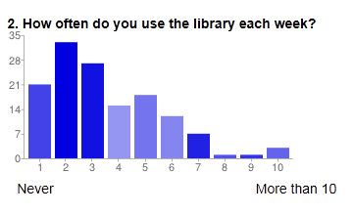
- 66% of respondents come to the library 2 -5 times a week
- 15% never come to the library (this is a concern – not even with their class?)
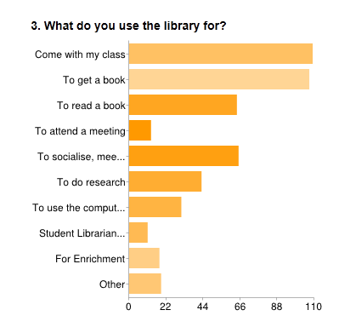
- Most respondents come to library with class, to get a book, to socialise and read
- Library not seen as much as a place to do research

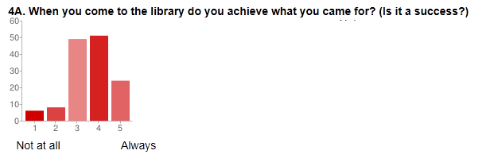
- 73% of respondents said they achieved what they came to the library to do
4B. When you did not achieve what you came to the library for, what would have helped?
- Most students said more books would have helped
- Some wanted more time with the librarians
- Some said nothing would have helped

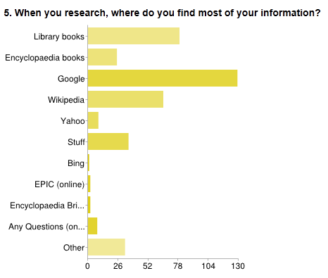
- Most students use Google, library books and Wikipedia for their research
(Need to do some serious promotion of EPIC and Encyclopaedia Britannica online)

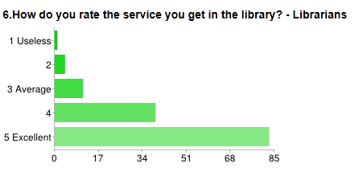

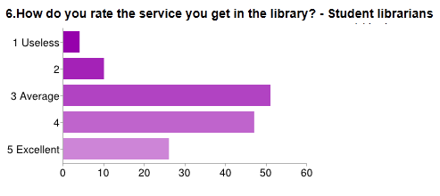

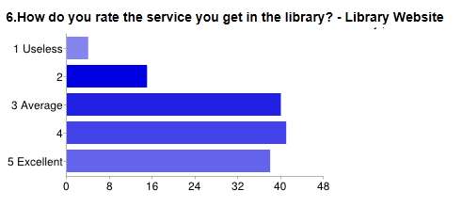
- Most respondents are happy with the service provided by the librarians (60% excellent), mostly happy with the student librarians (90% average – excellent) and happy with the library website (86% average to excellent)
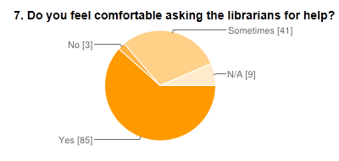
- Would like to work on the 29% who said sometimes they can ask the librarians
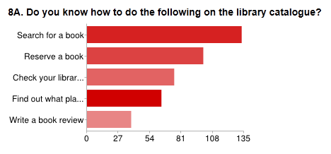
- 96% of respondents know how to use the catalogue to search for a book and 72% know how to reserve a book online.
- This familiarity with Access-It is very good, means the library orientation is working for this aspect, probably assisted by contributing schools having the same library system
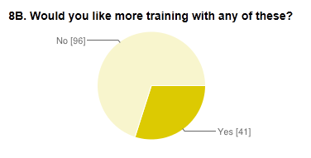
- Will keep teaching students to use the catalogue on an on-going, individual basis
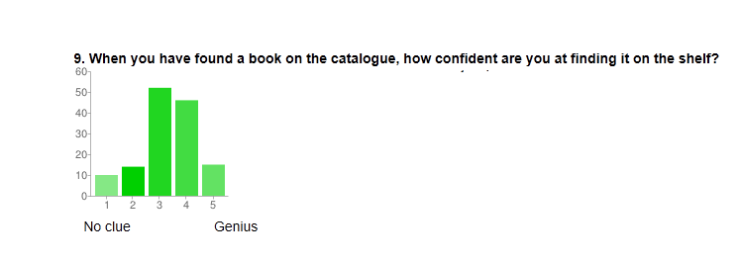
- 82% of respondents were confident about finding books on the shelves
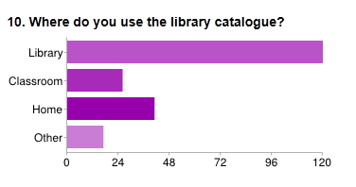
- Most respondents use the catalogue in the library but 30% also use it from home. This is pleasing as it was one of the reasons for getting a web based library system
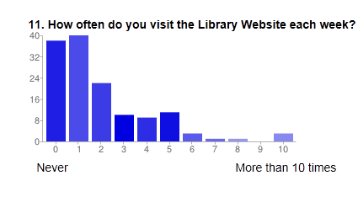
- 29% visited the website only once a week, 38% 2-5 times a week but 27% never visited the website.
- Need to carry on promoting the library website and the tools that are available
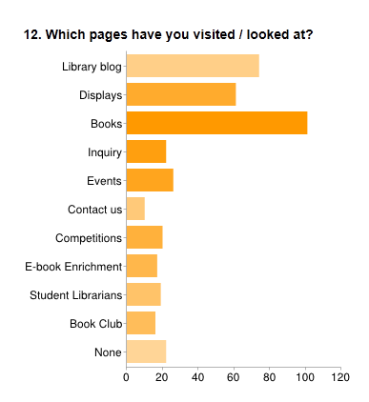
- Need to promote the Inquiry tools available on the Inquiry page
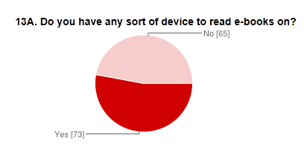
13B. What sort of e-reader device do you have?
- iPad (18), iPod (31), iPhone (8), Kindle (16), Laptop (3), Kobo (1)
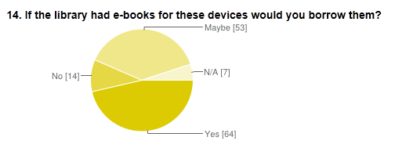
- Given that only about half the respondents have e-reader devices and less than half would definitely borrow e-books from the library (although 38% could probably be convinced eventually) it was decided not to go ahead with purchasing an e-book platform for the library next year. Also there is only one (Wheelers) available at present so no competition and it cannot lend to Kindles.
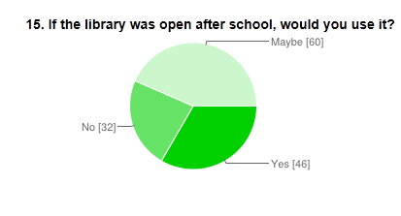
- Only 33% definitely wanted to extend the library opening hours after school. Not enough to make this a viable proposition at this stage.
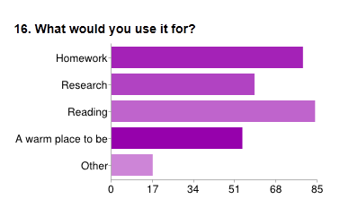

- Most respondents wanted the library open between 3pm - 4.30pm
18. What is the best thing about your school library?
- The books
- A great place to socialise and meet friends
- The librarians
- The cards
- The computers
19. What would you like to change about our school library?
- Nothing
- More books
- More beanbags / cushions / furniture
- E-books
- More computers
- Make it bigger
- More games
- Less noise
APPENDIX
4B. When you did not achieve what you came to the library for, what would have helped?
- more specific books for research, finding the right books for research , find better books, more subjects for books, a wider range of books
- more copies of a book (2), more books, more range of books, more of the books , more selection of books(2), to get more books, more copies of the book I wanted, bigger range of books
- if the library had more books about animals
- having some good books
- the books I want being here, but it's all good though.
- people retuning their book on time (2)
- look at all parts of the shelve to find the right book
- more books that are a bit more for adults
- easier to find a different book I like
- finding things quicker
- more time on computers, I would use the computer
- a tool that is easy to use to find answers
- librarians, a librarian free to help, more librarians to help , asking the librarian
- More time in the library
- my friends or my teacher
- having decent cards
- nothing (4 ), nothing, usually great help, nothing much
- I don’t know
- n/a (2)

18. What is the best thing about your school library?
- the books, all the books, the range of books, there are plenty of books to choose from, books, it has lots of books, it has heaps of books and resources, books, that it has lots of different books, the books, that it has heaps of books that are interesting and ones I haven't read, the selection of novels, all the amazing books, the books, range of books, the books that you can read, the range of books, it’s got heaps of books, the books, the book selection, it's got lots of good books, lots of books to choose from, books! the books, all the interesting books, books, the books, the books, it has good books, they have everything that you’re looking for, the books, lots of books, range of books, books, the variety of books, the range, all the books, all the good books, books, it has lots of good books, it has a wide choice of books, the books, it has a wide choice of books and tech, the books, the amount of books we have, range of books, it has a variety of books, large range of books, it's got a lot of cool books that I could read, the variety of books, the books, books, it has plenty of books, the range of different books, books, books, the books, books, books!!! book selection, the books, there are lots of books that will help you for research, lots of books to choose from, books , the books, lots of books, the range of books, the books
- new book shelf
- the range of books and the chance to ask for books to be added to the range
- I can find books that I want to read but I don't have at home, pretty easy to find books, it has several copies of popular books, getting books easily
- it has Terry Pratchett, it’s got comic books, graphic novels, it has the series I'm reading
- It's a great place to read and socialise, a good place to get books, to read and talk to my friends, it's a great place to read and socialise, it has lots of books and is a good place to read, its big, there’s a lot of good books to choose from, I like reading books there, you can met friends, coming into the school library on a really cold day and being able to be with friends, when you get kicked out of your class, it’s a warm place to be, its warm and the books are always new, you can enjoy reading books or just hanging with friends, it’s comfortable and warm! books/warmth, the books and that its always warm so if it’s raining you can hang out with your friends still just in the library, it is warm and we are allowed in there no matter what so we always have place to meet, meeting up with friends, it’s a good place to hang out
- the librarians are very helpful, friendly staff :) , the staff :) , the librarians, it has a wide variety of books and the librarians are very helpful, friendliness, the people, the friendly help I get when trying to find something, the librarians are really friendly and always help me find the book I want, the librarians, the service, the librarians
- the calm environment, a good place, it is a nice place to be, the quiet
- how many people use it
- reading :)
- beanbags, beanbags
- how the books are laid out and the book talks
- top trumps, top trumps, top trumps, cards, games
- the website and reserving
- computers, internet, computers, the computers
- it's local, it’s local, easy to access
- it caters to my every need
- everything, everything
- not sure

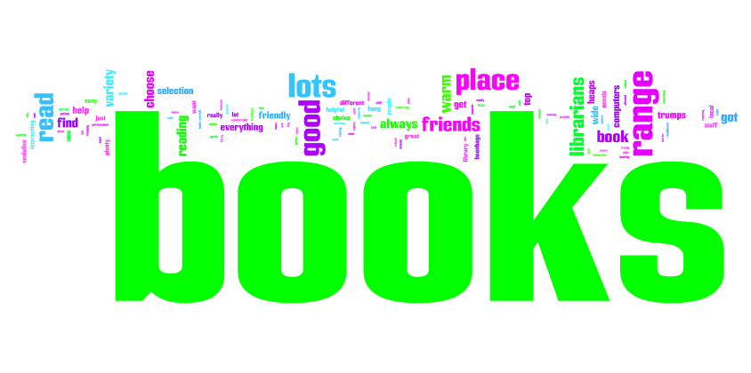
19. What would you like to change about your school library?
- nothing, nothing, nothing , nothing, nothing, nothing, nothing , nothing , nothing it’s a good library, nothing, nothing, nothing, nothing, nothing, none, nothing, nothing, none, nothing, nothing, nothing, nothing, nothing, nothing, nothing, I like it just the way it is, nothing, nothing, nothing, nothing, nothing, nothing, nothing, nothing, nothing, nothing, nothing, nothing it is pretty good, nothing, nothing, nothing, nothing, nothing, nothing, nothing, nothing, nothing, nothing much, nothing, nothing, nothing, nothing, nothing, nothing, nothing, nothing, nothing, nothing, nothing, nothing really
- bigger/more books, more books for our age group/level , have a wider range of books, more books, more books, the books and the amount, more variety in certain sections, more books, more science books, more variety of books, more books, more books, more books, the amount of books , MORE BOOKS! , more books, more range of books, more small books, more adult encyclopaedias
- more books people want to read - for example I needed a book on the Philippines for writing but didn't find one but I found a book on Palestine!!!!
- more copies of popular book, more copies of popular book, more copies of the more popular books?, more books on cherub or spys or army/sas
- more series of books, if you get more books in a series, more books eg the mortal cup series and demon princess etc
- possibly couches, more cushions\bean-bags, have more places to sit, more places to sit! Have more places to sit, more beanbags :), more beanbags & couches, more couches /places to sit, more pillows/beanbags
- open late on Friday.
- have e- books, e-books :D, to have e-books, e-books
- more book talks
- more computers, internet, use electronics
- more organized, have a list of where books are, books in less confusing orders, easier to find books, the books put in less confusing orders
- we could rent out movies and magazines, maybe getting some magazine subscriptions for popular magazines
- update library catalogue, the catalogue
- maybe make it bigger, bigger room, make it more bigger, having more room to sit down and more tables to work at, more room, bigger, for it to be bigger
- self issuing
- more Top Trumps, more board games
- making the books a bit better to find and the student librarians to be there instead of watching movies on computers
- being able to find books easily without help from a teacher or a student librarian.
- hot chocolate to buy, allowing fruits or veges in library
- less noise anyone who is too loud has to leave, I might build a wall between it and the ICT suite because when classes are there they are usually noisy.
- Raroa Knowledge net to website
- set up
- being able to plug in your music so you could play your music over a stereo system nothing
- n/a

